**Agile in Handy**

SRIRAM

**Preface**

I have been involved in IT Software development since 1997. I have unique combination of process, technical and industrial skills. Currently working as an agile leader in US MNC. As a Certified Agile Coach, I have expert level of knowledge in agile and practices with this combination I can help process and technology people, understand the agile world.

My agile coach journey started in 2011, when I was a part of Tata Consultancy Services. I practiced XP, Scrum, Lean Kanban and agile methods thoroughly over several years and my teams are highly successful in delivering products using agile techniques.

I am proficient in agile engineering, coaching practices and SAFe consulting practices... Worked in India, USA, and UK for TCS, Syntel agile customers, which creates a global agile experience and awarded as a best coach.

I have created agile websites and released books related to “Scrum Alliance Professional”, ”Agile Coaching”, “Agile A Key of Success” & “SAFe 4.0 Q&A”.

As a Senior Agile Consultant helped to improve the teams of developers and overall project management by increasing collaboration, innovation, and introducing techniques that promote adaptability and flexibility in the face of unpredictable circumstances.

I am releasing “Agile in Handy” to the Agile world made agile handy and expertise in short span of time to recollect everything at one shot.

**My sincere dedication to my agile guru’s, friends & family members with my agile journey……………………………………………………………………….. SRIRAM**

|  |  |
| --- | --- |
| ***Message from Agile Guru*** | |
| Congrats again for your book release and website launch. We are proud of you. All the best. This is indeed achievement. | Wow! This is fantastic news! Congratulations!  All the best to you with your SPC 4 Agile Coach career. |
| Regards, **Rakesh Khanna** Syntel Consulting Inc., | Interim CEO & President | Thanks,  **Susan Gibson**  Temenos LLC |CEO & Co Funder |

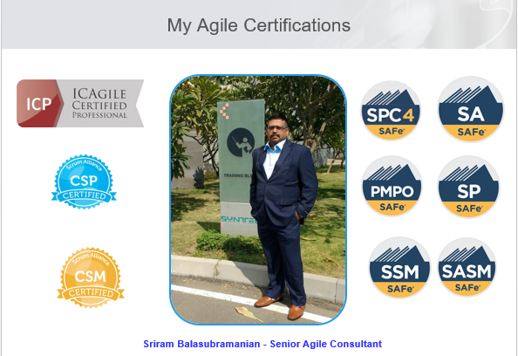

**Table of Contents**

|  |  |
| --- | --- |
| **Contents**  **Lesson 1 Agile in Handy** | **Page No**  **4** |

**Agile Paradigm Shift**

***"Agile has really done wonders for my career said Sriram." I was very conservative in my career progression without any independence in seeking ideas, despite having a great academic background and being known for regular and innovative output.***

***Normal People says ...”Success knocks your door only once but Achievers says “Knock the door of success until success opens the door to lead the Agile Life”***

***Agile Life brings Agility along with Mobility***

***“Never be a prisoner of your past, be an Agile leader of your future”***

***“If you are not loving Agile, You might be doing it wrong”***

***My Favorite things in life don’t cost any money. It’s really clear that the most precious resource we all have its “time” i.e., Agile Clock***

***Lean-Agile Leaders are “lifelong learners” who help teams build better systems through understanding and exhibiting the values, principles and practices of Lean, systems thinking, and Agile development to build the Agile Community***

***People are already doing their best; the problems are with the system, only management can change the system, we are key person to grow as an Agile Leader***

***“Being an Agile Leader, Exhibit a Lean Agile Mind-set, Lead the change in Agile fashion, Adapt the agile way, emphasize life-long learning, unlock the intrinsic motivation of knowledge worker & Decentralize the decision making are the good qualities”***

***“Embrace the Lean Agile Mind-set with great value through – Respect for people and culture, Quality flow, Innovation and Rentless Improvement for the better way to lead the Agile Career”***

**Agile in Handy**

**Agile Intro**

**What is an Agile?**

“Agile” is an umbrella term used to encompass dozens of different techniques and disciplines (e.g. Scrum, XP, KANBAN, etc.), all aimed at the iterative, incremental development of software.

The various disciplines | flavours of Agile are:-

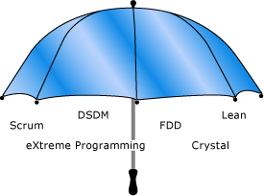

**What is the importance of Agile?**

The importance of the Agile are:-

* Reduce Turnaround time for features
* Predictability of Market Releases content and thinking
* Ability to handle complex product enhancements

**Why Agile?**

The main reason for the agile existence due to:-

* Project priorities change’s frequently
* Need to respond to customer requirements and market dynamics
* Promote team work and less reliance on individual heroics
* Course correction and continuous improvements

**What is Agility? What does business agility mean?**

“Agility is the ability to deliver customer value while dealing with the inherent project unpredictability and dynamism by recognizing and adapting to change”

**What is an Agile Mind-set?**

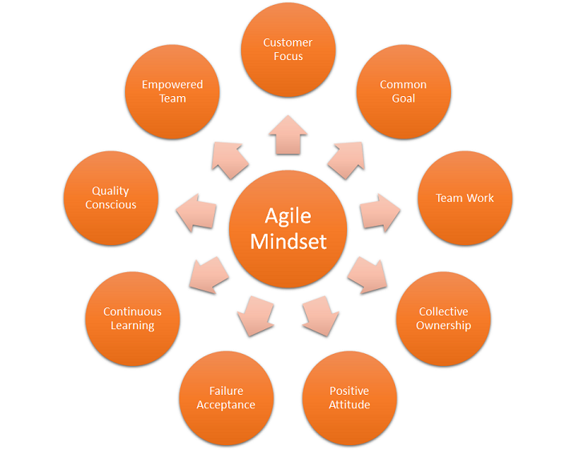

**What is Agile Manifesto? (Agile 4 Values)**

**- Individuals and interactions over Process and Tools**  
Self-organization and motivation are important, as are interactions like co-location and pair programming.  
**- Working software over Comprehensive Documentation**  
Working software is more useful and welcome than just presenting documents to clients in meetings.  
**- Customer collaboration over Contract Negotiation**  
Requirements cannot be fully collected at the beginning of the software development cycle, therefore continuous customer or stakeholder involvement is very important.  
**- Responding to change over Following a plan**  
Agile methods are focused on quick responses to change and continuous development.

**What are the Agile Principles? (Agile 12 Principles)**

1. Customer Satisfaction 2. Welcome Changes

3. Frequent Delivery 4. Collocated Teams

5. Motivated Individuals 6. Face-to-Face Contact

7. Working Software 8. Constant Pace

9. Continuous Attention 10. Simplicity

11. Self-Organization 12.Regular Reflection

**What is need or demand for Agility?**

The demand of agility depends on the following factors:-

* Value-driven delivery
* Faster time to market
* Better transparency
* Responsiveness to change
* Self-managing teams
* Sustainable pace of development
* Reduced process waste
* Better aligned with customer needs

**What are the key Agile practices?**

The key agile practices are:-

* Evidence based development – Empiricism
* Limit work in progress ->Defer commitment | Match demand with capability | Progressive Elaboration | Adaptive Planning | Emergent Design
* Visualize your work
* Faster Feedback Cycle
* Collaboration
* Release early and often | Release on Demand
* Continuous or Relentless Improvement

**Scrum**

**Tell me Scrum Framework in short?**

Agile has 4 Values & 12 Principles. SCRUM is a simple process framework.

SCRUM has:-

**3 Legs**: Inspect, Adapt, Transparent

**3 Roles**: Product Owner | Scrum Master | Development Team

**3 Artifacts**: Product Backlog | Sprint Backlog | Product Increment

**4 Meetings**: Sprint Planning | Daily SCRUM | Sprint Review | Sprint Retrospective

**1 Activity**: Product Backlog Refinement

**5 Values**: Focus | Courage | Openness | Commitment | Respect

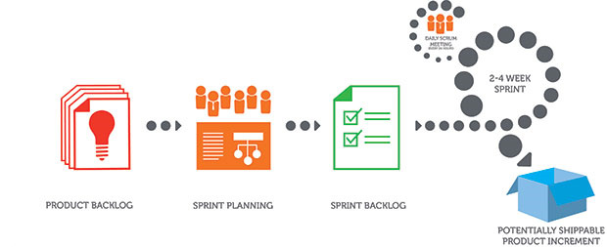

**Product Backlog** -> Ordered list of items to be worked on for the product

**Sprint Backlog** -> Product backlog items selected to work in the Sprint and the work plan to complete those items

**Product Increment** -> Completed product backlog items in a sprint, which are ready to be delivered to the customer

**Product Backlog Refinement** -> A meeting to get the product backlog items ready for the next few sprints

**Sprint Planning** -> A meeting to create the sprint goal and plan the work for the sprint

**Daily SCRUM** -> A daily 15 minute time boxed event for the Development Team to synchronize activities and create a plan for the next 24 hours

**Sprint Review** -> A meeting to inspect the product increment and adapt the product backlog if needed

**Sprint Retrospective** -> A meeting for the scrum team to inspect and adapt the process, people and tools

**XP**

**What are the overall flow of XP?**

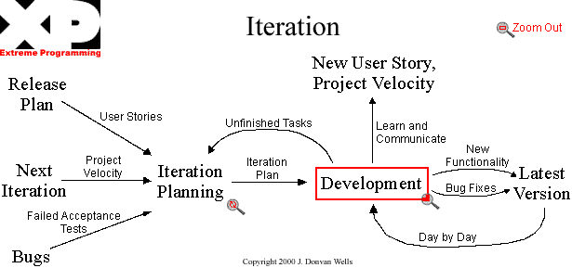

**What is XP 5 values?**

XP 5 values are: Simplicity, Communication, Feedback, and Respect & Courage

**What are the XP Practices?**

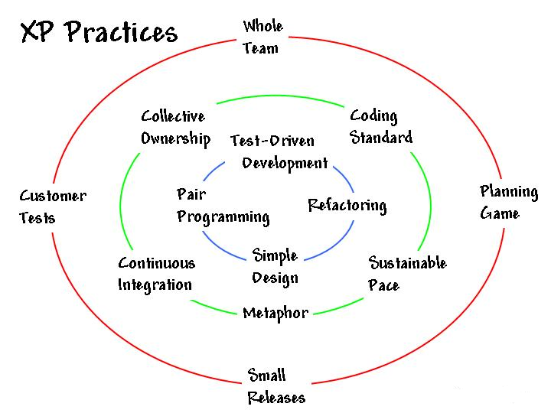

**What are the XP Concepts?**

**Test Driven Development ->** is a method that involves writing automated test code first and developing the least amount of code necessary to pass that test later

**Collective Ownership ->** The entire team takes responsibility for the whole of the system

**Continuous Integration ->** The Code is integrated and tested many times a day, one set of changes at a time

**Metaphor ->** The metaphor consists of domain specific elements and shows their interconnectivity

**Refactoring** -> Improve code quality without changing the behavior

**Pair Programming**-> In Pair programing, the entire code is written with two developers at one machine, with one keyboard and one mouse

**Technical debt** -> Design and Coding, Imperfection that need correction

**Iterations** -> Design | Code | Test | Release within a specific duration

**Last Responsible moment** -> Delay till when it’s absolutely needed

**Stories** -> Self-contained elements taken up for implementation

**Lean**

**What is the purpose of Lean?**

- Lean Development is focused on eliminating waste from a system and improving value to the customer. Lean is to minimize WIP

- Lean is for continuous improvement

**What are the Lean Principles & Practices?**

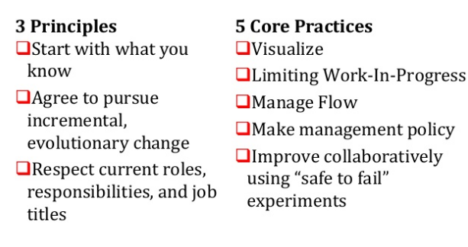

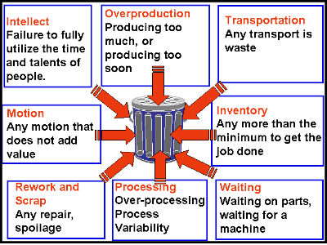**How will you eliminate waste in Lean?**

**What are the Value Stream Mapping Terms?**

**Value Stream Mapping** is a lean management method for analysing the current state and designing a future state for the series of events that take a product or service from its beginning through to the customer

**Lead time** is the time taken from when an issue is logged until work is completed on that issue. Lead time is what customer sees

**Cycle Time** is a measure of the time a work item takes to complete. The time a user story takes to get from the backlog to the done

**W I P (Work In Progress):** Number of work units in progress.

**Throughput**: The amount of material, data, work units that enters into a system and passes to generate output. Velocity, in Agile terms, can be the similar to this

**Little’s Law**: Cycle Time = W I P / A C R* Where *ACR = Average Completion Rate

**Total Cycle Time** = Value Added Time + Non Value Added Time

**Cycle Time Efficiency**: (Value Added Time / Total Cycle Time) * 100

**Agile Planning**

**How Agile planning is done?**

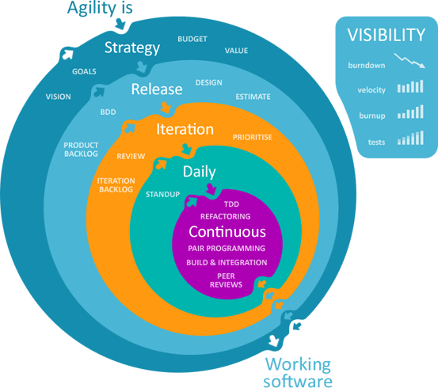

**What are prioritization methods in agile planning?**

The prioritization methods are:-

* MoSCoW Prioritization
* 100 point method
* Kano analysis
* Relative weighting Model

**MoSCoW Prioritization:** Primarily used in Dynamic System Development Method (DSDM)

**100 Point Method:** Each member given 100 points

Those item with the highest number of points is ranked first

**Kano Analysis:** Exciters or Delighters – Features which command extra price | Linear – More the better | Threshold – Must haves

**Relative Weighting Model:**

* Benefit of Presence & Penalty for absence is considered
* Relative weighting (1 to 9 ) is provided by the P O’ s expert judgement
* Desirability for each of the theme is calculated based on the relative weights

**What is an Iteration Planning?**

In Iteration Planning – Identify the Iteration goal, Select User Stories, Split into Tasks & Estimate the tasks

Each story is taken, broken into tasks and estimated.

Team commitment is arrived at before including that within the iteration

The iteration activities are

* Be Specific, add all tasks (meetings, UT, bug fixing etc.,)
* Add tasks of non-development nature-testing, documentation
* Dependencies between user stories need to be handled
* Task should not typically take more than a day

If tasks appear wrong, re-plan accordingly

**User Stories and Estimation**

**What is User Story and its format?**

User Stories provide a Light Weight approach to managing requirements for a system. Short statement of function captured in an index card or in a tool.

**Format of User Story**

**As a <role> I can <activity> so that <business value>**

E.g., As a user, I can login and gain access to the intranet, so that I can collaborate with all the organization

**What are 3 C’s of User Story?**

1. Card – Written on a card

2. Conversation –Details captured I conversations

3. Confirmation – Acceptance criteria confirm that the story is done

**What are types of User Story?**

**Requirements**

Functional requirements

Non-Functional requirements

**Technical User Story**

Compliance to standards and regulatory concerns

An item of work in the Software Debt backlog that pays off a chunk of debt that is undesirable and valuable to the Product Owner”

**Spikes Stories**

A story or task aimed at answering a question or gathering information, rather than implementing product features, user stories, or requirements. Items needing investigation towards backlog grooming

**What is INVEST in User Story?**

**“Independent”**

The User story should be self-contained, in a way that there is no inherent dependency on another user story

**“Negotiable”**

User Stories, up until they are part of an iteration, can always be changed and rewritten

**“Valuable”**

A User Story must deliver value to the end user

**“Estimable”**

You must always be able to estimate the size of a user story

**“Scalable”**

User Story should not be so big as to become impossible to plan or Task or prioritize with some level of certainty

**“Testable”**

The User Story or its related description must provide the necessary information to make test development possible

**How will you split the user stories?**

* Can be split on data boundaries
* Can be split alongside operations
* Horizontal components
* Functional and Non Functional Components
* Maintain the INVEST check
* Like “Shasimi” – Fish Slice

**Agile Metrics**

**What are the process metrics chart?**

* Sprint | Iteration Burn down chart
* Release Burn down chart | Risk Burn down chart

**What is the difference between burnup & burndown?**

* Burndown chart shows how much work or effort remaining
* Burn up chart shows how much work completed

**What do you think Velocity as Metrics?**

Nothing but the team capacity based on two factors mainly requirement ability & team capability

**How will you estimate the Velocity?**

**Use Historical Values** – From the similar teams under similar technology, domain, tool landscape and working environment

**Run an Iteration** - Run a few sample iterations and arrive at a narrow range of projected velocity per sprint. Typically 3-4 iterations will help to arrive at a projected value which is reasonably accurate range

**Make a Forecast -** When there is no scope for using historical values or sample sprints, make a forecast. Fill an iteration capacity with tasks derived from randomly selected stories. This can serve as indicative velocity

**What is Velocity?**

* Velocity = User story points delivered in a sprint
* Measure of work Team completes in a Sprint
* Planning Tool
* Only stories accepted by PO qualify for velocity calculation
* Varies across teams
* Projected Vs Actual Velocity

**Sprints SP Committed SP Accepted Velocity**

**1 20 16 16**

**2 24 24 24**

**What is Participatory Decision Model?**

Participatory decision models present different ways to engage the team in the decision making progress:-

- Mechanism in place for making decisions while still keeping everyone engaged in the project. - It is not realistic to expect the team to achieve total agreement on all issues and decisions

- These mechanism are called Participatory Decision Models

**1. Simple Voting**

A simple “For” or “Against” Voting

**2. Thumps Up | Down | Sideways**

Show of Thumps up, down or sideways around the room is a more efficient way of achieving a simple vote still allowing some time to discuss other options

Members holding the thumb sideways may be neutral on the idea, might have a conflict, concern or question that needs further investigation

**3. Jim Highsmith’s Decision Spectrum**

Team members indicate how they feel about a decision by placing a checkmark on the spectrum ranging from “Fully in Favor” to “Mixed Feelings” to “Absolutely No” or Veto. It could be created on a whiteboard with permanent markers

**4. Fist of Five**

People vote by showing the number of fingers that indicates their degree of support

One Method: A first (No Fingers) means to support, while raising five fingers indicates full support

Other Method: (Most Popular)

**One Finger:** I totally support this option

**Two Fingers:** I support this option with some minor reservations that we probably don’t need to discuss

**Three Fingers:** I have concerns that we need to discuss

**Four Fingers:** I object and wants to discuss the issue

**Five Fingers:** Stop, I am against this decision

**What are the Earned Value Metrics?**

**Metrics Definition Calculation**

PPC Planned % Complete Iteration # / Total Iterations

APC Actual % Complete Points Delivered / Total Points

PV Planned Value PPC * BAC

EV Earned Value APC * BAC

CPI Cost Per Index EV / AC

SPI Schedule per Index EV / PV

SV Schedule Variance EV – PV

CV Cost Variance EV - AC

NPV Net Present Value NPV = ∑ Ct / (1+r) t

**Books for References**

1. “Coaching Agile Teams” - by Lyssa Adkins
2. “Quiet Leadership” - by David Rock
3. The Wisdom of Team – by Jon R Katzenbach
4. Art of Agile Development - by James Shore and Shane Warden
5. “Emotional Intelligence Coaching” by Steve Neale; Lisa Spencer-Arnell; Liz Wilson
6. “Applied EI” (2006) by Sparrow and Knight
7. Agile Project Management with Scrum by Ken Schwaber
8. The Software Project Manager’s Bridge to Agility by Michele Slinger and Stacia Broderick
9. Agile Product Management with SCRUM by Roman Pichler
10. Succeeding with Agile Software Development using Scrum by Mike Cohn
11. Agile Estimating and Planning by Mike Cohn
12. User Stories Applied for Agile Software Development by Mike Cohn
13. Agile Retrospectives by Esther Derby and Diana Larsen
14. Agile Game Development with Scrum by Clinton Keith
15. Agile Testing by Lisa Crispin and Janet Gregory
16. Coaching Agile Teams by Lyssa Adkins
17. The Leaders Guide to Radical Management by Stephen Denning
18. What is Agile?
19. Scrum Guide – Ken Schwaber, Jeff Sutherland  Refer [Scrum Guide](http://www.scrumguides.org/)
20. A guide to the SCRUM Body of Knowledge SBOK™ Guide – Scrum Study

**Website for References **

1. [*https://inteamwetrust.com*](https://inteamwetrust.com/)
2. [*http://www.slideshare.net/alexeypikulev/getting-started- with-the-team-trust-canvas*](http://www.slideshare.net/alexeypikulev/getting-started-with-the-team-trust-canvas)
3. [*http://hrweb.mit.edu/learning-development/learning-*](http://hrweb.mit.edu/learning-development/learning-topics/teams/articles/stages-development)
4. [*topics/teams/articles/stages-development*](http://hrweb.mit.edu/learning-development/learning-topics/teams/articles/stages-development)
5. [www.agilecoachinginstitute.com/resources/competency-](http://www.agilecoachinginstitute.com/resources/competency-model/)  [model/](http://www.agilecoachinginstitute.com/resources/competency-model/)
6. [www.coachfederation.org/](http://www.coachfederation.org/)
7. <https://howardgardner.com/multiple-intelligences/>
8. <https://scaledagileframework.com>

**My Agile Books**

1. Scrum Alliance Professional
2. Agile Coaching
3. Agile A Key of Success
4. Handy Agile
5. SAFe 4.0 Q & A
6. Agile in Handy
7. Agile Coaching in Handy

